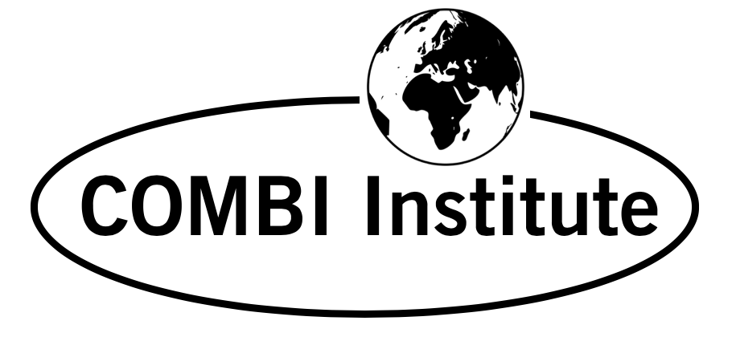
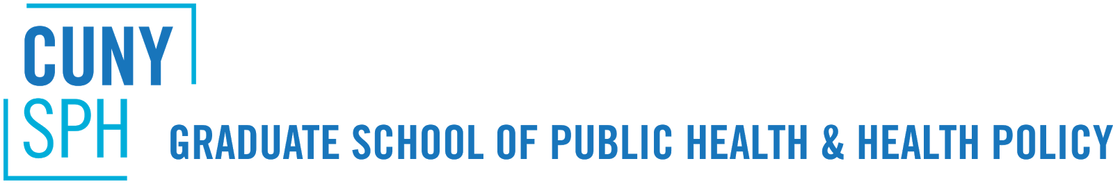
City University of New York (CUNY)

INTERNATIONAL COURSE

Offered by the City University of New York Graduate School of Public Health and Health Policy

In association with the CUNY Center for Systems and Community Design

and the COMBI Institute

SOCIAL AND BEHAVIOR CHANGE

“COMMUNICATION FOR BEHAVIORAL IMPACT (COMBI)
IN HEALTH AND SOCIAL DEVELOPMENT”

CUNY Graduate School of Public Health and Health Policy
55 W. 125th Street, New York, NY 10027
June 5-16, 2023

Faculty from: World Health Organization (WHO), United Nations Children Fund (UNICEF), The Advertising Council

Course Coordinator: Dr. Everold N. Hosein
Senior Communication Advisor/Consultant, World Health Organization (WHO)
Communication Consultant to UNICEF, UNFPA, UNDP, UNWOMEN
President, The COMBI Institute; Distinguished Scholar, CUNY Graduate School of Public Health and Health Policy
__________________________________________________________________________________________________
Applications are now being accepted for this 10-day training program on COMMUNICATION FOR BEHAVIORAL IMPACT (COMBI) IN HEALTH AND SOCIAL DEVELOPMENT offered at the CUNY Graduate School of Public Health and Health Policy. The course will focus on behavioral and communication challenges in a variety of health topics and social development issues such as non-communicable diseases, environmental education, early childhood stimulation and development, violence against women and children, and other public health concerns. The training will be applicable to any area facing these behavioral challenges, including the behaviors of policy makers.

Course Description:
This 10-day course focuses sharply on communication planning for behavioral impact in health and social development. Behavioral results are viewed as the primary end-goals of health and social development programs. The course stresses that behavioral impact comes with effective communication programs purposefully planned for behavioral results, and not only directed at awareness creation, attitude change, advocacy, or public education. The private sector experience in successfully using Integrated Marketing Communication (IMC) for consumer behavioral results points to an approach for achieving behavioral objectives in health and social development. WHO has been applying this IMC approach to a variety of desired health behaviors over the past 20 years in over 70 countries and refers to it as “COMBI” (Communication for Behavioral-Impact). UNICEF country offices in about 20 countries have been using the COMBI approach within its program communication, communication-for-development (C4D), and social and behavior change (SBC) efforts. UNFPA, UNEP, UN WOMEN and UNDP have also been using the COMBI approach.

COMBI is not about producing posters and T-shirts and pamphlets. It applies in an integrated way the disciplines of community engagement, interpersonal counselling, personal selling, health education, mass communication, folk media, social media, marketing (including village-level marketing traditions), public relations and public advocacy, administrative mobilisation, advertising, and market research – directed at achieving desired behavioral outcomes.

The course is intended for:
Health and social development professionals who have the responsibility for designing, supervising or managing health education/promotion/communication, information-education-communication (IEC) programs, and other strategic communication/social mobilization/program communication efforts to achieve specific behavioral results in health and social development. Prior communication experience is not required for this training.

Learning Objectives:
Participants will learn how to apply the 10-step planning process of COMBI in the strategic planning of communication programs for behavioral results. Topics to be covered include:
- COMBI (Communication for Behavioral Impact)
- COMBI Foundational Principles
- Behavior Adoption and Maintenance
- Basic Communication Principles
- Role of Communication in Behavior Adoption/Maintenance
- Marketing Principles from Integrated Marketing Communication (IMC) for Bridging the Knowledge/Action Gap
- Social and Behavior Change Communication
- Sexual Health Communication and Sexual Attitudes Reassessment (SAR)
- Integrated Communication Action Areas for COMBI—Administrative Mobilization, Public Relations and the Mass Media, Advocacy, Community Engagement and Group Communication, Advertising and Social Media, Personal Selling/Interpersonal Communication, Point of Service Promotion
- Marketing Research and Behavioral Impact Evaluation
- The 10-Step COMBI Planning Process and COMBI Planning Practicum

All participants, in working groups, will be involved in developing a COMBI Plan for presentation on the final day of the training program.

The Course Coordinator:
Dr. Everold N. Hosein, President, COMBI Institute Inc., and Senior Communication Advisor-Consultant, World Health Organization (WHO), Geneva. The COMBI Institute (TCI) is a not-for-profit corporation dedicated to developing COMBI capacity worldwide and based in New York, USA. Dr. Hosein also serves as a COMBI Communication Consultant to UNICEF, UNFPA, UNEP and UN WOMEN. Professor Hosein is a Distinguished Scholar at the Graduate School of Public Health and Health Policy of the City University of New York.

Tuition

US $2,950 per person (includes costs for all course materials). A non-refundable advance of US $1,000 of the US$2,950 tuition will be expected to be paid by May 1, 2023 upon acceptance to the course. The remaining tuition fee will need to be paid by May 29, 2023. Tuition fees will be paid to The COMBI Institute by bank wire transfer and payment instructions for this will be provided at the time of acceptance into the course. Please note that no scholarships will be available for the 2023 course.

Accommodation/Meals:
Accommodation and meals will be the responsibility of individual participants or their sponsors. CUNY will offer some advice on suitable accommodations near the CUNY/SPH. possible once acceptance to the course has been granted.

Language:

The language of instruction will be English.

Schedule:

This two-week course runs June 5 – June 16, 2023.
Sessions will be held Monday through Friday (no program over the weekend) from 9:00 a.m. to 5.30 p.m. Registration on the first morning will be at 8.30 am. Working groups will be expected to meet on their own time for additional work outside the formal daytime sessions.

Application Process and Deadlines:
Applicants should submit an application form to Dr. Everold Hosein, Course Coordinator, via e-mail: Everold@gmail.com or Everold@combiinstitute.org, by March 13, 2023. Applications after this date will be considered on a space availability basis. The application form is attached.
Visa Requirements: All participants from overseas must have valid visas to attend this course

For More Information: Contact Dr. Everold Hosein at e-mail: Everold@gmail.com or Everold@combiinstitute.org. For Information about CUNY and the conference location contact Ms. Hind Kasem at the CUNY Center for Systems and Community Design: Hind.Kasem@sph.cuny.edu

City University of New York - Graduate School of Public Health and Health Policy

International COMBI Course, June 5 – June 16, 2023

Application Form

1. Applicant Information
Full Name:
 | Last | First | Middle
Your Personal Primary Address:
 | Street Address
 | City/Town | State/Province | Country and ZIP/Post Code
Phone Contact: | ( ) | Passport/ID Number:

E-Mail Address:
Position/Title:

Organisation:

Organization Address:
 | Street Address
 | City/Town | State/Province | Country and ZIP/Post Code

2. Motivation to Join the CUNY SPH COMBI Course
Please write a short paragraph as to why you want to join the course and why you should be selected to participate in the CUNY SPH COMBI Course.

Please submit to: Dr. Everold Hosein via email – Everold@gmail.com or Everold@combiinstitute.org

***

